My COVID-19 Plan

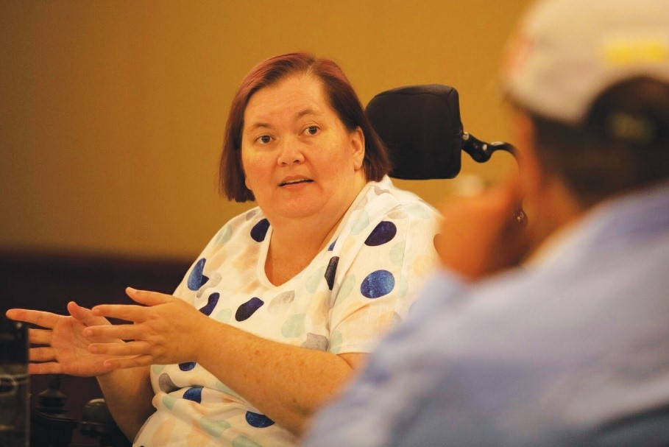

A GUIDE TO ASSIST YOU TO DEVELOP YOUR OWN EMERGENCY PREPAREDNESS PLAN FOR COVID-19

My COVID-19 Plan

Complete the following My COVID-19 Plan and put in a safe and easy to find place in your home

Communication

I have my phone and computer or tablet to be able to stay in touch with people or call people in emergency.
Action: Write the name of your phone company here:

- I have enough data and credit to keep in touch
Action: Write the name of the company the data for your computer is with here:

- Other things I need to do
Action: Other important information about my communication:

Management of Health:

- I have my list of who to call
Action: Write your list of emergency contacts here

- I know if medical emergency – call 000 emergency

- If I develop COVID-19 symptoms, I will call my doctor first or 13 HEALTH on 13 43 25 84
Action: Write down the name of your support person for making health decisions

- Then call your service provider to let my support workers know that I have COVID-19 symptoms

- I have my important health information printed and accessible including my medications, blister packs, essential supplies and contact information if I have someone who helps me with my health decisions
Action: Write down a list of your current medications

- I have a plan for looking after my mental and physical health and well being if I have to stay home for a long time
Action: Write down a list of essential supplies you need:

- I know if I run out of essentials (food; medication) and there is nobody to help me, I can call the Community Recovery Hotline on 1800 173 349

Action: Things I am going to do to look after my mental and physical health and wellbeing:

Assistive Technology
- I have my power sources and back-up power supplies
Action: Write down your current assistive technology maintenance schedule

Action: Write down your current assistive technology maintenance people

Notes:
Repairs to AT in an emergency are considered by the National Disability Insurance Agency (NDIA) as urgent repairs. More information: https://www.ndis.gov.au/news/4142-urgent-assistive-technology-repairs

Personal Support
- I have clear COVID-19 personal support instructions for my support staff, including any new support staff
Action: Write down where copies of your important documents are kept

- I have communicated my COVID-19 care instructions to all of my support staff
Action: Write down the names of your back up list of support workers here

- I have written COVID-19 care instructions down and posted them in an accessible location at home.

- I have discussed my play with my emergency contact.
Action: Write down the name and phone number of who you will call in an emergency

- I have copy of my NDIS plan or My Aged Care support plan
Action: Write down phone numbers of service providers, NDIA and other supports here

Assistance animals and pets
- I have a plan for who will look after my animal if I become unwell.
Action: Write down the name and phone number of your vet here

- I can develop a detailed preparedness plan for my assistance animal or pet using this information:https://www.qld.gov.au/emergency/dealing-disasters/prepare-for-disasters/prepare-pets).
Action: Write down the name of people who will help you with your animals if needed
Action: Write down your animals need here

Transport
- I will call ahead to plan appointments

- I will make different plans to make sure I don’t have to leave home

- I have a plan for different ways to travel if I need to go out
Action: Write down your transport options here

- I have someone who can help me make decisions about transport
Action: Write down the contact details of who can assist you with transport.

Living Situation
- I have made or checked by home safety plan
- I have considered ways to protects me and others at home if we need to isolate from each other if someone gets sick
- I have a plan to increase household cleaning so that surfaces are wiped down regularly to decrease spread of germs
Action: Write any notes here

Social Connectedness
- I have an emergency contact list
Action: Write down your contact list of name and phone numbers here

- I shared my emergency contact list with my support network for staying connected and in touch with people
Action: Write down your plan for staying connected and in touch with other people here

