What to expect when you get disability services – coronavirus (COVID-19)
Easy read information for people with disability

About this book
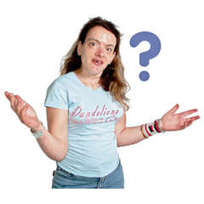 | This book is about the disability services you receive.  Disability services include things like:
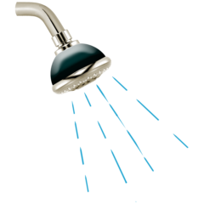 | - getting help to have a shower
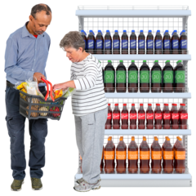 | - having someone help you with shopping
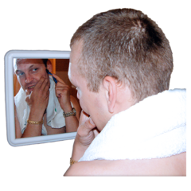 | - learning how to do things for yourself.
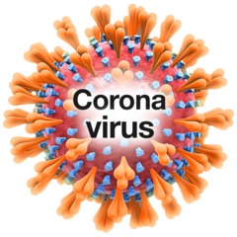 | The way people get disability services has changed because of coronavirus.  Coronavirus is also called COVID-19.
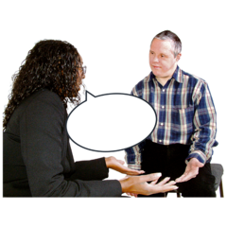 | This book will tell you how disability services have changed.  This book will help you know what to expect when you get disability services.

Why have disability services changed?
Coronavirus has meant the way we do a lot of things have changed.
This is because coronavirus can make you sick.
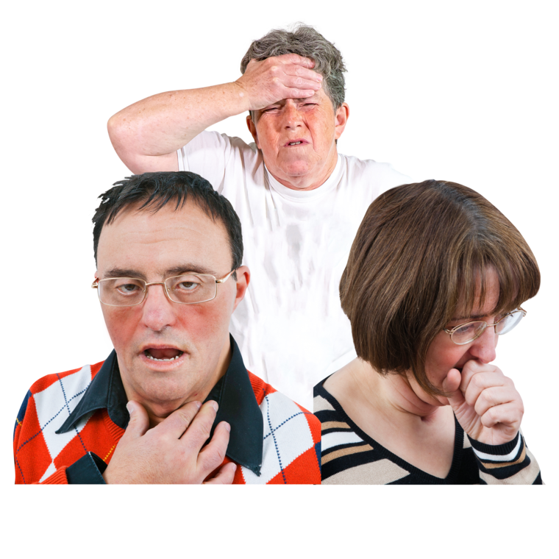 | It is important that people stay away from each other, so they don’t get sick.
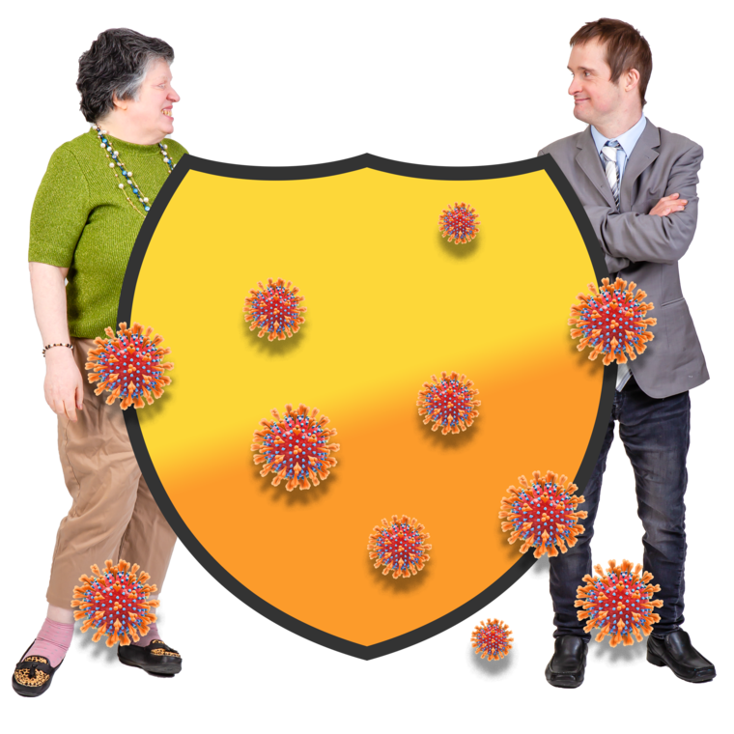 | If people can’t stay away from each other they need to make sure they are safe.
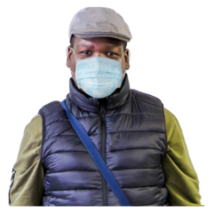 | People can stay safe by  - wearing a face mask
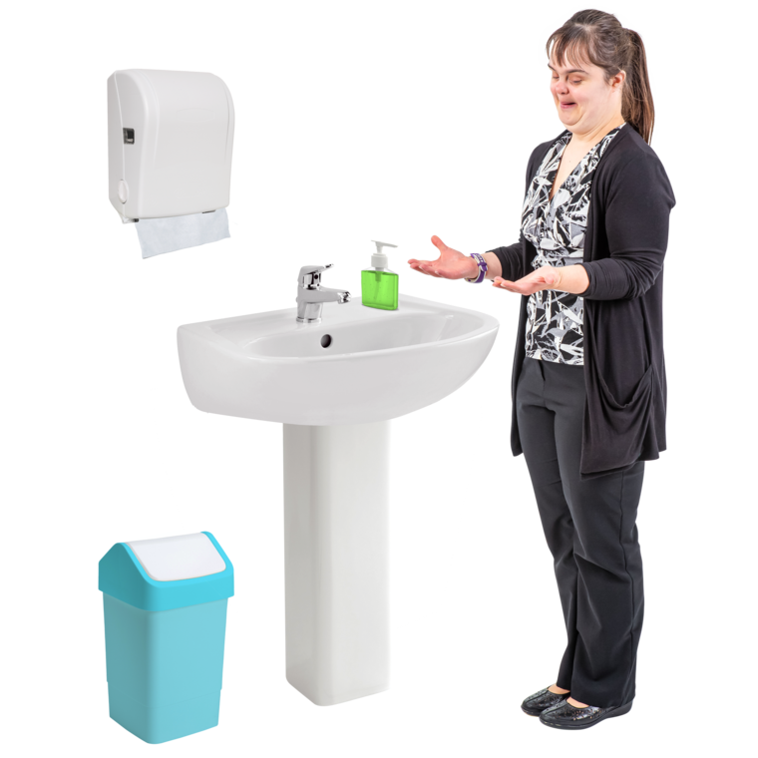 | - washing your hands
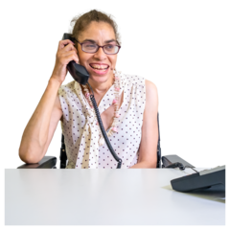 | - talking over the phone instead of meeting in person.
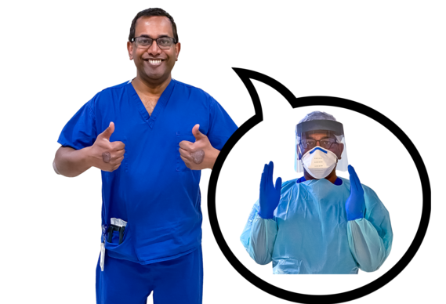 | Disability services has changed to make sure everyone stays safe.

What do the changes look like?

You have some services face-to-face
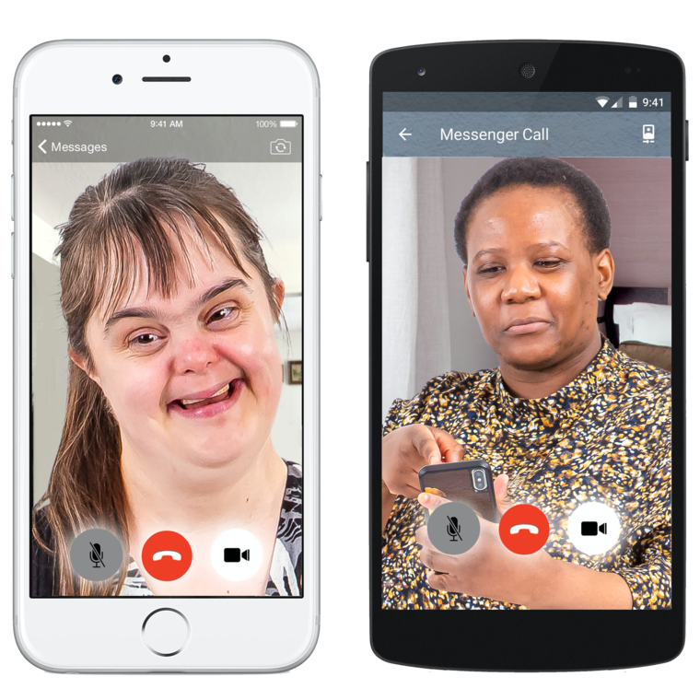 | You might keep getting some services over the phone or the internet.
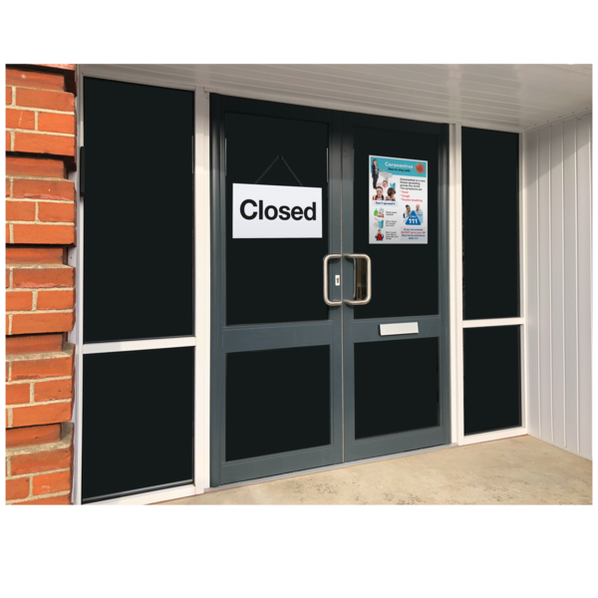 | Example:  Kelly used to go to the gym. This stopped because of coronavirus.
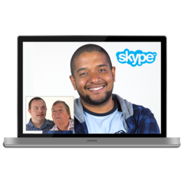 | For a while she was doing exercises with her support worker over the internet.  This was to make sure she didn’t get sick.
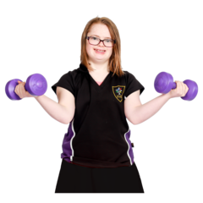 | Now that less people are getting sick the rules for coronavirus are changing.  This means Kelly can do some sessions at the gym. She can also do some sessions over the internet.
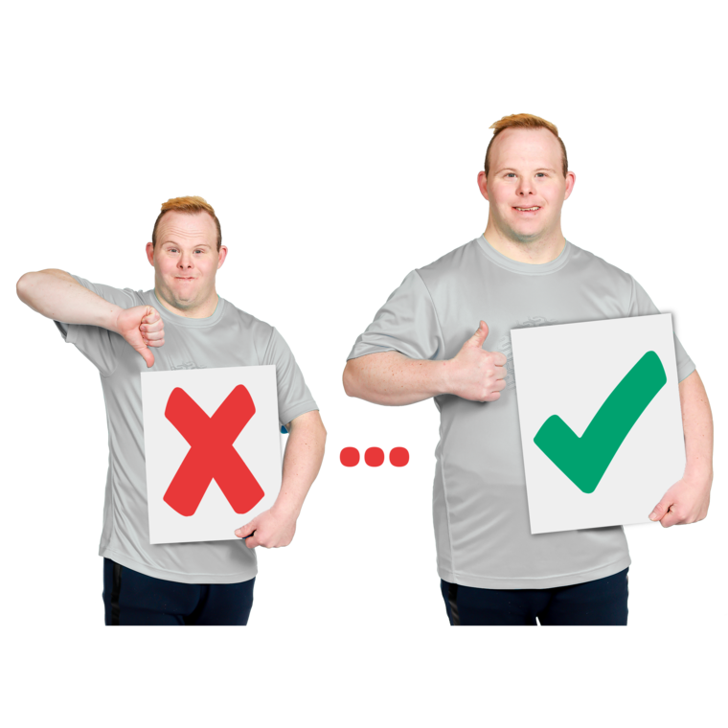 | If less people get sick and there are less restrictions, you might get more services face-to-face.  ‘less restrictions’ means making some of the rules less strict.

Your support worker might wear different clothes
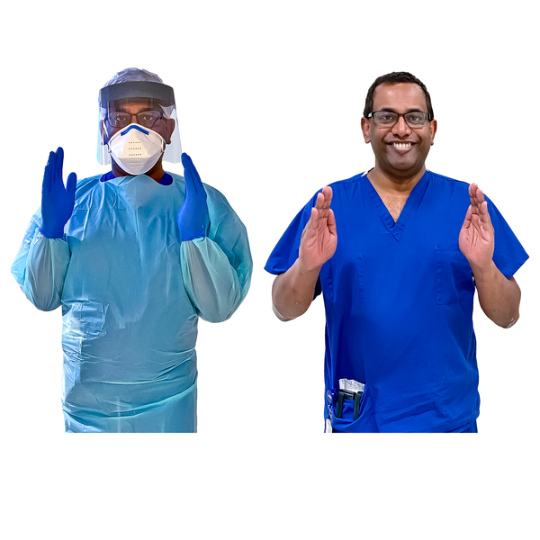 | If you need support face-to-face your worker might wear different clothes.
This could include:
- a face mask
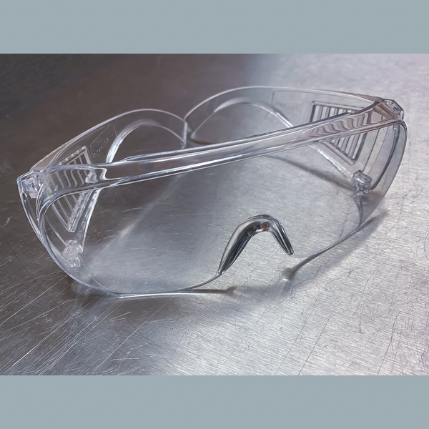 | - glasses
 | - gloves
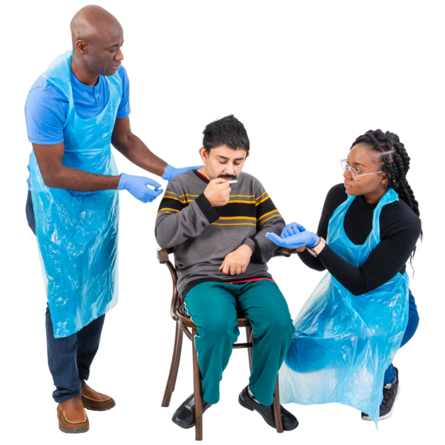 | - a plastic apron.  Wearing these clothes will stop you or your support worker from getting sick.

You might need to wear a mask
 | If you are feeling unwell your worker might ask you to wear a face mask.
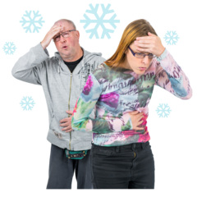 | Your support worker will ask how you are feeling.  This will let them know if you need to wear a face mask or not.

Your support worker might keep doing things differently
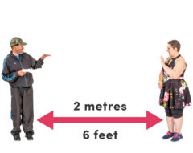 | Your support worker will try to keep away from you.  Your support worker might ask everyone to stay away from each other.
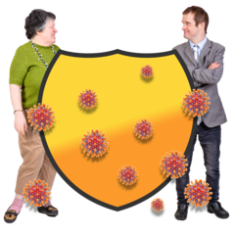 | This is because we need to stay away from each other to keep safe.
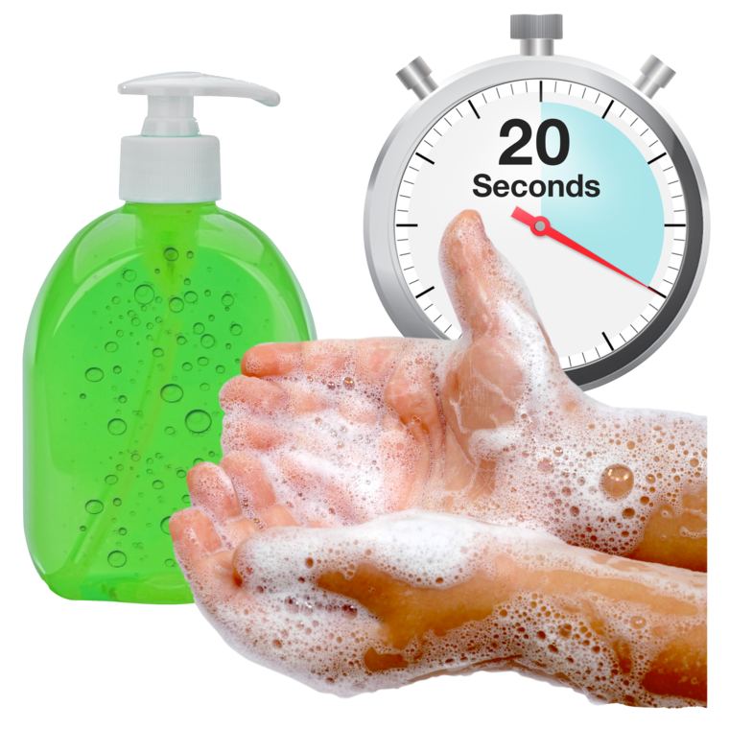 | Your support worker needs to wash their hands a lot.  You need to wash your hands a lot.
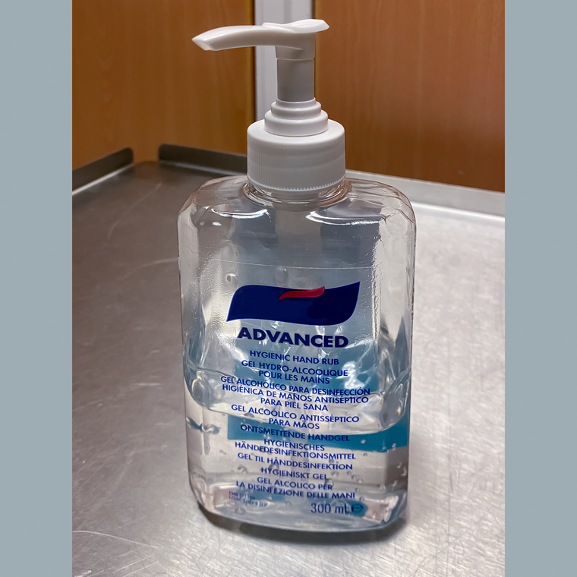 | Your support worker might use hand sanitizer to clean their hands. This might smell a bit strong.
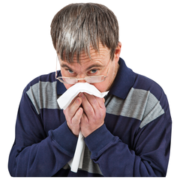 | If your support worker coughs or sneezes they need to cover their mouth.  They might cough or sneeze into their elbow.

How do I stop myself getting sick?
 | To stop getting sick you should stay home.
 | This can stop you catching coronavirus from people who are sick.
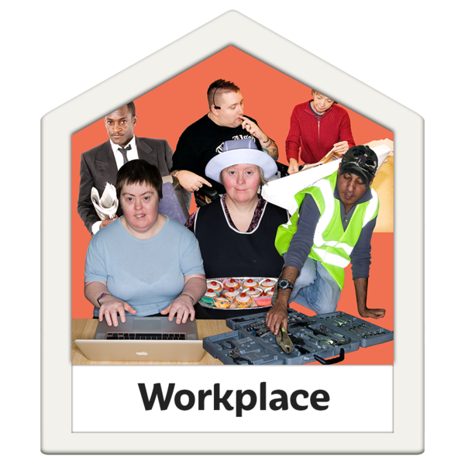 | You can now leave your house for many reasons:  - to work and study if you can’t do this from home
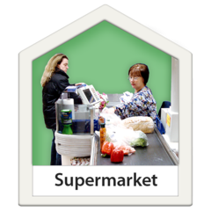 | - to go shopping
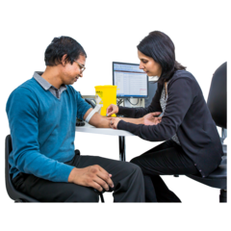 | - to go to the doctor
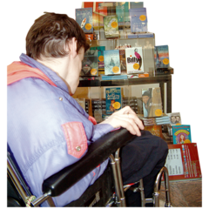 | - to go to the library  .
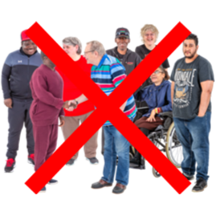 | You need to be careful when leaving your home.  To keep yourself and your friends and family safe:  - Try to stay away from crowded areas.
 | - Wash your hands a lot
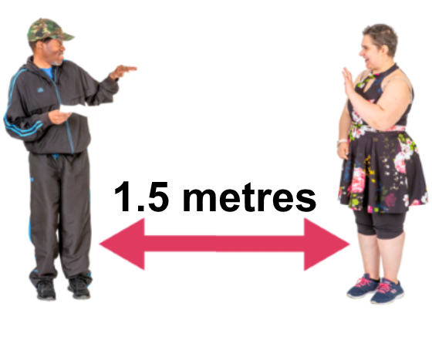 | - Stay more than 1.5 metres away from other people.

How do I know if I have coronavirus?
 | You should talk to your doctor if you have:
 | - a fever
 | - a cough
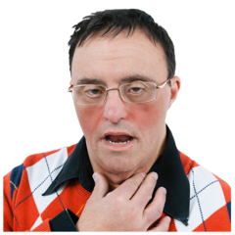 | - a sore throat
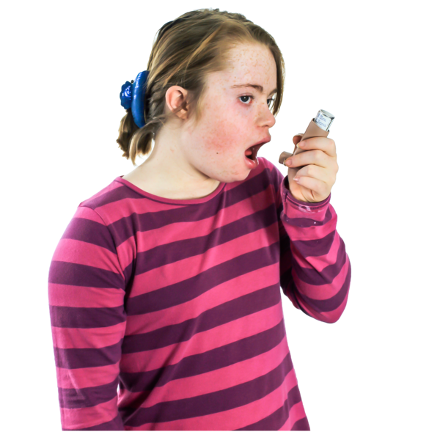 | - trouble breathing.
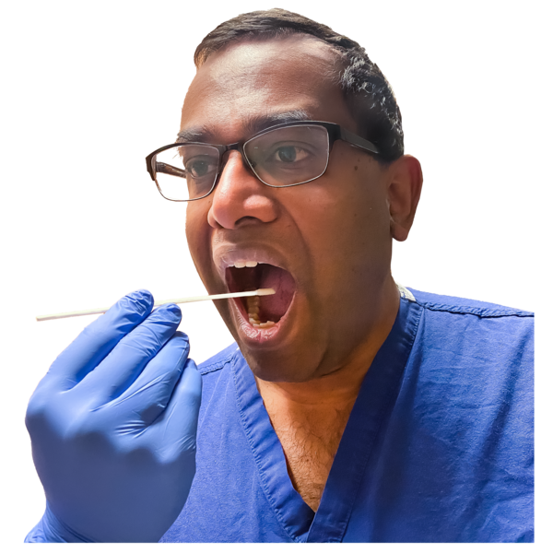 | Your doctor can help you get tested to see if you have coronavirus.
If you have coronavirus you might get very sick.
If you are having trouble breathing, you should call 000 and ask for an ambulance.

What will happen if I get sick?
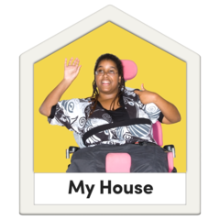 | If you get coronavirus you will have to stay home for 14 days.  If you have been near someone with coronavirus you will have to stay home for 14 days.
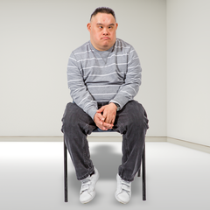 | If you stay home, you need to stay away from other people living in your home.
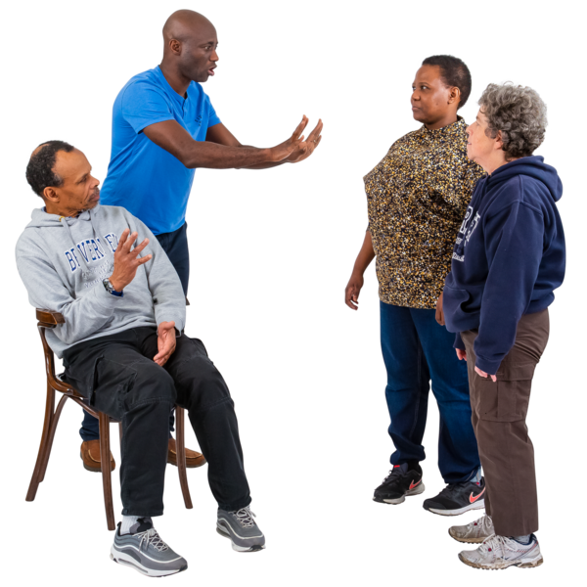 | You can’t have any visitors.
 | The Department of Health and Human Services (DHHS) will call you and tell you what you need to do.

Where can I find out more?
To find out more about coronavirus you can:
- go to the Department of Health and Human Services (DHHS) website <https://www.dhhs.vic.gov.au/coronavirus>
- call 1800 675 389.

To receive this document in another format phone 1300 880 043, using the National Relay Service 13 36 77 if required,
or email Office for Disability <ofd@dhhs.vic.gov.au>
Authorised and published by the Victorian Government, 1 Treasury Place, Melbourne.
© State of Victoria, Department of Health and Human Services, May 2020.
Available at Department of Health and Human Services Coronavirus page <https://www.dhhs.vic.gov.au/coronavirus>

