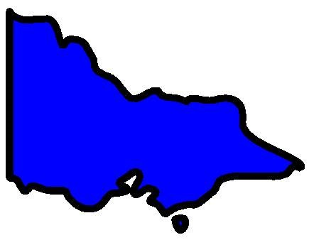

**2 August 2020**

**COVID - 19 in Melbourne**

There are still too many people getting COVID - 19.

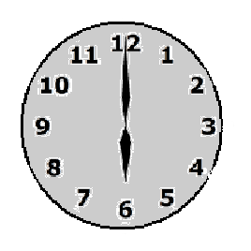

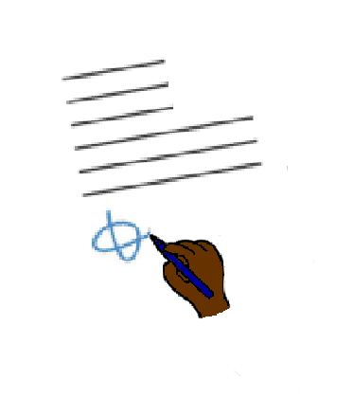

New rules start at **6 pm today.**

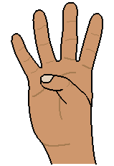

It is **stage 4** shut down.

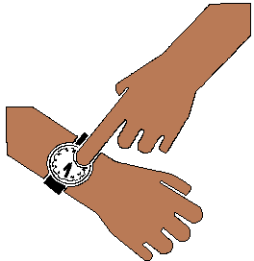

From tonight.



You **must** stay home.

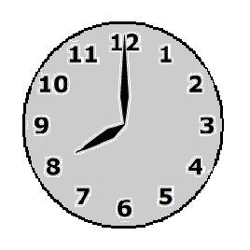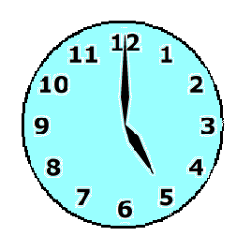

Every night

* after 8 pm

until

* 5 am.

Based on the Victorian Premiers Press conference 2 August 2020.

Developed by Access Easy English. 2 August 2020. Australia

Images from Freepikpsd, Mayer-Johnson, Picto-Selector, PrintableCalendarTemplate