Coronavirus (COVID-19) resources for people with disability from diverse communities
Contents
Information for the Aboriginal community 2
Information for lesbian, gay, bisexual, trans and gender diverse, intersex and queer and questioning (LGBTIQ) people with disability 3
Information for people with disability from culturally diverse backgrounds 4
Information for rural and regional Victorians 5
Information for women with disability 6

Information for the Aboriginal community
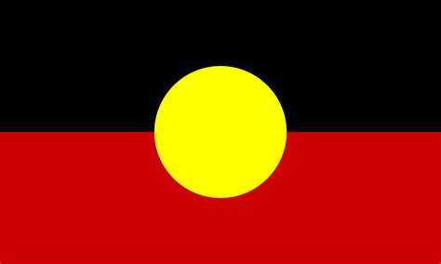

First Peoples Disability Network (FPDN)
A series of short films to help slow the spread of coronavirus (COVID-19) and ensure families and communities stay safe.
- Watch Self-care and coronavirus short film
<https://www.youtube.com/watch?v=19haDtcTk7s&feature=emb_logo>
- Watch Social distancing short film
<https://www.youtube.com/watch?v=YOfj-YzCTPs>
- Watch Stop coronavirus in its tracks (handwashing) short film
<https://www.youtube.com/watch?v=jM3WJsnD0qI>
- Watch NDIA changes supporting NDIS participants through coronavirus short film
<https://www.youtube.com/watch?v=L45dugpp4bY>

Department of Health and Human Services
Read Coronavirus (COVID-19) information for Aboriginal and Torres Strait Islander communities <https://www.dhhs.vic.gov.au/coronavirus-information-aboriginal-communities>

Victorian Aboriginal Health Service (VAHS)
Information about changes VAHS have been made to help stop the spread of coronavirus (COVID-19) and ensure families and communities stay safe.
Visit Victorian Aboriginal Health Service <https://www.vahs.org.au/>

First peoples Disability Network Australia
An organisation of and for Australia’s first peoples with disability, their families and communities.
Find out about First Peoples Disability Network Australia <https://fpdn.org.au/covid19/#jump>

Information for lesbian, gay, bisexual, trans and gender diverse, intersex and queer and questioning (LGBTIQ) people with disability
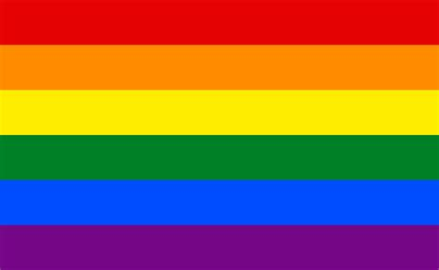

Thorne Harbour Health
Information about how to maintain physical distancing and sexual relationships during coronavirus (COVID-19).
Visit Thorne Harbour Health <https://thorneharbour.org/covid19/sexcovid19/>.

Drummond Street
LGBTIQ specific counselling services through queerspace. Counsellors can offer support with:
- Sexuality and gender identity
- General counselling
- Case management services
Find out more about queerspace <https://www.queerspace.org.au/our-services/queerspace-counselling/>.

Other organisations
- Rainbow Health Vic <https://www.rainbowhealthvic.org.au/>
- Spectrum Intersections <https://www.spectrumintersections.org/>
- Rainbow Rights Self Advocacy Group < https://www.voicestogether.com.au/self-advocates/find-group/vic/rainbow-rights-and-advocacy-group/>
- Victorian Pride Centre <https://pridecentre.org.au/#>
- Black Rainbow https://blackrainbow.org.au/
- Network MindOUT <https://www.lgbtihealth.org.au/networkmindout>

Information for people with disability from culturally diverse backgrounds
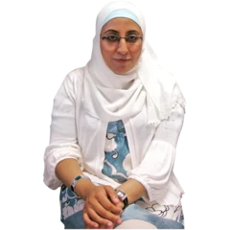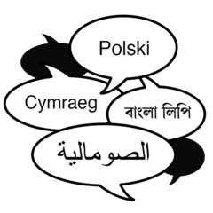

Department of Health and Human Services
Coronavirus (COVID-19) translated information for people from culturally diverse backgrounds.
Read Translated resources - coronavirus (COVID-19) <https://www.dhhs.vic.gov.au/translated-resources-coronavirus-disease-covid-19>

Action on Disability in Ethnic Communities (ADEC)
Pictorial resources and information and advocacy support for people with disability from culturally diverse backgrounds.
Visit the COVID-19 webpage <https://adec.org.au/covid-19/>

Migrant Resource Centre – North West Region
Individual and self-advocacy for people from culturally diverse backgrounds.
Visit Migrant Resource Centre <https://www.mrcnorthwest.org.au/disability_services>

Other organisations
National Ethnic Disability Alliance (NEDA) <http://www.neda.org.au/>
Adult Multicultural Education Services (AMES) <https://www.ames.net.au/>
Ethnic Communities’ Council of Vic (ECCV) <https://eccv.org.au/>
Centre for Multicultural Youth (CMY) <https://www.cmy.net.au/>
Foundation House <https://foundationhouse.org.au/>

Information for rural and regional Victorians
Disability advocacy services are available for people with disability from rural and regional areas, including:
- Gippsland Disability Advocacy Inc
<https://www.gdai.com.au/>
- Barwon Disability Resource Council
<https://www.bdrc.org.au/home-67146>
- Grampians Disability Advocacy
< http://grampiansadvocacy.org.au/>
- Regional Disability Advocacy Service
<https://rdas.org.au/services/>
- Southwest Advocacy Association
<http://www.southwestadvocacy.org.au/swaa/>
Read the full list of Victorian disability advocacy services <https://www.daru.org.au/find-an-advocate>.
Read the full list of Victorian self advocacy groups <http://saru.net.au/Groups>.

Information for women with disability
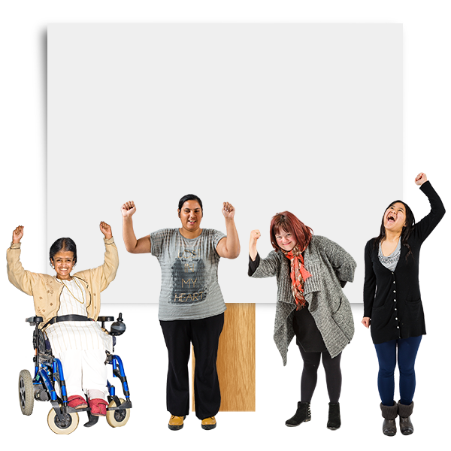

Women with Disabilities Australia
Aims to improve the rights, safety and well-being of women and girls with disability in all areas of life.
Find out about Women With Disabilities Australia < https://wwda.org.au/>.

Women’s Health West
Delivers family violence services and undertakes health promotion actions.
Find out about Women’s Health West <https://whwest.org.au/>

Women with Disabilities Victoria
A peak body of women with disabilities in Victoria.
Find out about Women with Disabilities Victoria <https://www.wdv.org.au/>.

WIRE
Free support, referral and information for all Victorian women, nonbinary and gender-diverse people.
Find out about WIRE <https://www.wire.org.au/>.

Yellow Lady Bugs
An organisation dedicated to the happiness, success and celebration of autistic girls and women.
Find out about Yellow Lady Bugs <https://www.yellowladybugs.com.au/>.
To find out more information about coronavirus and how to stay safe visit
DHHS.vic – coronavirus disease (COVID-19)
<https://www.dhhs.vic.gov.au/coronavirus>
If you need an interpreter, call TIS National on 131 450
For information in other languages, scan the QR code or visit
DHHS.vic –Translated resources - coronavirus (COVID-19)
<https://www.dhhs.vic.gov.au/translated-resources-coronavirus-disease-covid-19>
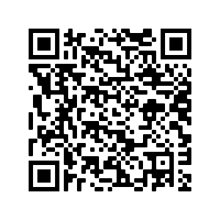
For any questions
Coronavirus hotline 1800 675 398 (24 hours)
Please keep Triple Zero (000) for emergencies only
To receive this document in another format phone 1300 651 160 using the National Relay Service 13 36 77 if required, or email Office for Disability <ofd@dhhs.vic.gov.au>
Authorised and published by the Victorian Government, 1 Treasury Place, Melbourne.
© State of Victoria, Australia, Department of Health and Human Services, 14 October 2020.
Available at: DHHS.vic – Information for people with disability - coronavirus (COVID-19) <https://www.dhhs.vic.gov.au/information-people-disability-coronavirus-disease-covid-19>

