Coronavirus (COVID-19) changes to disability supports and services
June 2020
This document is about changes to expect when you receive disability supports and services in your home or when you visit a service in the community because of coronavirus (COVID-19).

What is coronavirus (COVID-19)?

- Coronavirus (COVID-19) is a virus that has affected many people around the world.
- A virus is an illness or disease that can spread easily from one person to another person.
- Coronavirus (COVID-19) spreads through close contact with an infected person; mostly face-to-face or within a household. Close contact means greater than 15 minutes face-to-face or the sharing of a closed space for more than two hours with someone who has coronavirus (COVID-19).
- Coronavirus is also called COVID-19.

What changes to expect when you are receiving disability supports and services
To protect you from getting coronavirus (COVID-19), service providers will continue to minimise face to face contact and find other ways to support you.
If they can, they will do their work with you by video apps and telephone.
If you have to see someone face-to-face:
- they will try to keep 1.5 metres away from you
- they will ask you about your health before you meet
- they will not let many people into the same area at once
- everyone will wash their hands before anything else happens
- there will be hand sanitiser and tissues
- it will probably be a short appointment
- if they sneeze, they will cover their mouth and nose with a tissue
- if they cough, they will cough into their elbow.

They will do everything they can to protect you and others from getting coronavirus (COVID-19). If less people get sick and restrictions continue to change, service providers may increase face-to-face contact.
If you are well the service provider will not need much personal protective equipment.

What is personal protective equipment?
Personal protective equipment means things like special gloves and masks that can stop coronavirus (COVID-19) spreading. It is sometimes called PPE.

What protection will a provider use if I might have coronavirus (COVID-19) or I have tested positive for coronavirus (COVID-19)?
The service provider will use quite a lot of personal protective equipment if:
- it is suspected (awaiting a COVID-19 test result) or known that you have a coronavirus (COVID-19) infection
- you have been in close contact with someone with coronavirus (COVID-19) and are in quarantine for 14 days
- if it’s not possible to tell if you or someone in your home is at risk of having coronavirus (COVID-19).
They might also ask you to wear a surgical mask.
The table below lets you know what kind of equipment the service provider might use in those situations.
Kind of protection | Providing care that involves touching the client, body fluids or equipment | Whenever entering the room of the client
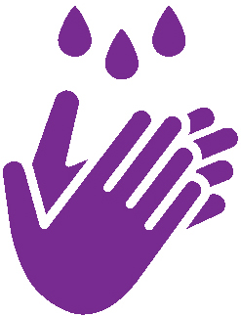  Hand hygiene | Yes | Yes
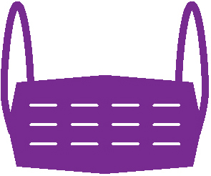  Surgical mask | Yes | Yes
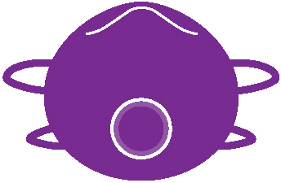  N95/P2 mask | No | No
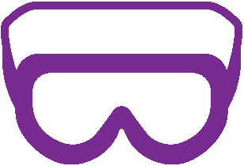  Eye protection | Yes | No
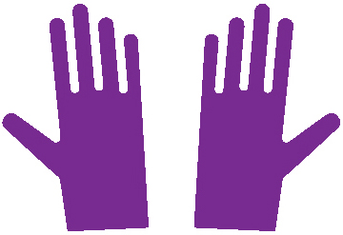  Gloves | Yes | Yes
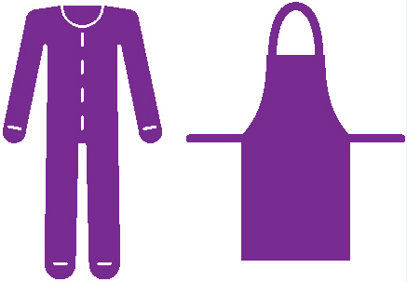  Fluid resistant gown or plastic apron | Yes | No
You should continue to receive the necessary supports and services, including medical or other appointments. However, services may change to protect you and others from being infected or from spreading coronavirus (COVID-19).

What protection will a provider use if I’m fine?
If you are well, and there is no reason to think that you have been exposed to coronavirus (COVID-19), the service provider will use basic equipment and hygiene.
The table below lets you know what kind of protection equipment the service provider might use if you are fine.
Kind of protection | Providing care that may involve exposure to blood, body fluids, secretions, excretions, touching oral mucosa, or medication assistance | Providing non-contact care or support
Hand hygiene | Yes | Yes
Surgical mask | No | No
N95/P2 mask | No | No
Eye protection | No | No
Gloves | Yes | No
Fluid resistant gown or plastic apron | Yes | No

How do I stop myself getting sick?
To stop yourself getting sick you should stay home.

If you leave your home, you need to be careful. You can now leave your house for many reasons:
- to work and study if you can’t do this from home
- to go shopping
- to go to the doctor
- to go to the library and do other things in the community.
To keep yourself and your friends and family safe try to stay away from crowded areas.
Continue to wash your hands often, stay more than 1.5 metres away from other people and stay home if you feel unwell.

What will happen if I get sick?
If you have had close contact with a person with coronavirus (COVID-19), or you have tested positive for coronavirus, you must quarantine for 14 days. You will be notified by the Department of Health and Human Services and advised of what you must do.
If you are in self-quarantine or self-isolation, you can’t:
- leave that place except in an emergency
- allow other people into the home if they don’t live there
- be closer than 1.5 metres to others in the home.
Stay at home and avoid all gatherings of more than two people including yourself. This reduces the chances of transmission, protects the health system and saves lives.
During self-quarantine you should not leave the house for any reason unless for:
- medical attention. If medical attention is required that is not an emergency, telehealth should be used where possible
- exercise, sun and fresh air the backyard of your house or on the balcony of your apartment or hotel room. You should also stay 1.5 metres away from other people.

Staying safe
To keep yourself, and your friends and family safe there are three key actions that Victorians are being asked to continue as restrictions are eased:
- Keep your distance – stay 1.5 metres away from others.
- Practise good hygiene.
- Stay at home if you are unwell.

Looking after yourself – if you feel unwell
If you have serious symptoms, such as difficulty breathing, call 000 and ask for an ambulance. Tell them if you also have other respiratory symptoms.
If you begin to feel unwell, and have a fever or a cough, sore throat, shortness of breath, chills, runny nose, or loss of sense of smell or taste you should get tested for coronavirus (COVID-19).
Contact the 24-hour hotline 1800 675 398 or call your doctor and mention your symptoms and risk factors. They will determine if you need to be tested for coronavirus (COVID-19).

Further information
If you have difficulties getting food or necessities, call 1800 675 398 for support.
If you need an interpreter, first call the free national Translating and Interpreting Service (TIS) on 131 450. Then request the hotline on 1800 675 398.
More information on coronavirus (COVID-19) is available on the Victorian government Coronavirus disease (COVID-19) website <https://www.dhhs.vic.gov.au/coronavirus>
Note: Further information will be provided on what the changes mean for people living in disability residential services.
To receive this document in another format phone 1300 880 043, using the National Relay Service 13 36 77 if required, or email Office for Disability <ofd@dhhs.vic.gov.au>
Authorised and published by the Victorian Government, 1 Treasury Place, Melbourne.
© State of Victoria, Department of Health and Human Services, May 2020.
Available at the Department of Health and Human Services Coronavirus webpage <https://www.dhhs.vic.gov.au/coronavirus>

